TECHNICAL PROJECT REPORT

# Title of Invention / Project:

# Team Members / Inventors:

|  |  |  |  |  |  |
| --- | --- | --- | --- | --- | --- |
| **S. No.** | **Name** | **Department** | **Designation** | **Mobile** | **E-Mail** |
| 1. | Yuvraj Sharma | IOT | Student | 8559070434 | aryanhead005@gmail.com |
| 2. | Shubham Jain | IOT | Student | 8607725788 | shubhamrockmail@gmail.com |
| 3. | Aayush Jain | IOT | Student | 8437179916 | jaayush014@gmail.com |
| 4. | Khushal Thakur | ECE | Mentor | 9646030764 | khushal.thakur@cumail.in |
| 5. | Anshul Sharma | ECE | Mentor | 9478697475 | anshulsharma.ece@cumail.in |
| 6. | Kiran Jot Singh | ECE | Mentor | 9463909689 | kiranjotsingh.ece@cumal.in |
| 7. | Divneet Singh Kapoor | ECE | Mentor | 9878422653 | divneet.ece@cumail.in |

Section – 1 (IPR Related)

# Brief Abstract (500 words):

* Problem your project is solving

As the temperature of our surroundings keep on changing at a frequent rate, it is difficult to realize and maintain the correct speed of our fans and exhaust system. This device could automatically detect the temperature of your room and control the speed of fans and exhaust system which could make your body comfortable according to the surrounding environment.

* How are you solving that (solution)?

We have built an automatic temperature controlled fan using Arduino which could easily sense and detect the room temperature and then increase or decrease the speed of your fans and exhaust systems. Our device automatically sense the change in temperature using Thermistor and gives command to fans and exhaust systems to control their speed.

* Additional modifications that can cater to improved solution

1. Also using Wi-Fi system we could control the speed of our fans and exhaust system, as per the requirement.

2. By using Bluetooth in our mobile phones we can also switch on or switch off our fans and exhaust system.

3. We can install a proper application in our mobile phones which would show room temperature and other stuff related to it.

# Existing state-of-the-art and Drawbacks in existing state-of-the-art

(*Brief background of the existing knowledge*)

|  |  |  |
| --- | --- | --- |
| **S. No.** | **Existing state of art** | **Drawbacks in existing state of art** |
| 1 | AdvancedTemperature Controlled Fans | Very expensive |
| 2 |  |  |

# Novel/Additional modifications that you can propose to improve upon drawbacks

*(List down the features)*

* Feature 1

Use Wi-Fi system to control the speed of fans and exhaust system according to the comfort of the user.

* Feature 2

Control and get notified about temperature using mobile phones via Bluetooth and Wi-Fi.

# Advantages

(*List down the advantages, if each feature is incorporated)*

* Adv 1

It is cheap and thus can be used by working class.

* Adv 2

It can be easily produced and executed.

* Adv 3

Low maintenance cost.

# Block Diagram

(*Functional diagram depicting the flow of information in your system. Do not define exact components, only use generic terms. Must include modifications as well.)*

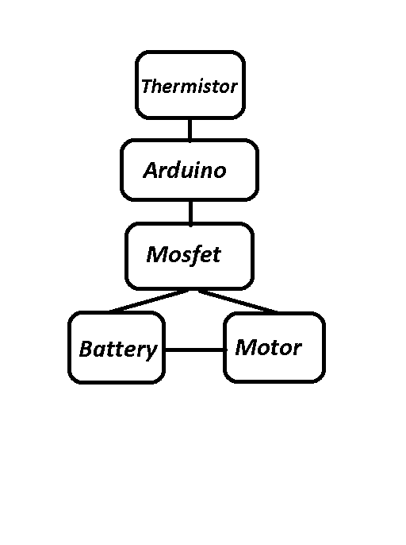

Section – 2 (Real Project)

# Materials

(*List down the Components, Equipment, etc. actually used in the project*)

* **Battery with cap**

Description:

Voltage= 9 volts

Non- rechargeable

Used for- toys, watch, etc

* **Arduino UNO**

Microcontroller-ATmega328

Operating voltage- 5V

Input voltage- 7-12V

Input voltage- 6-20V

Digital I/O pins 14 (6 of which provide PWM)

Analog Input pins- 6

* **Breadboard**

Description:

400 tie points

2 Power Lanes, Tie-pints 100

1 Double-strip, Tie-points 300

Size- 8.2* 5.5* 0.85 cm

Voltage/current- 300V/3-5A

* **Jumper**

Wire length: 20cm

The male ends meant for insertion into standard

0.1inch female socket

The female ends are meant for insertion onto standard

0.1inch male headers

* **Thermistor**

Model : NTC 10D-9

* 10K ohm Resistor
* **Mosfet**

2N7000 Small Signal Mosfet

Used for low power switching applications with different lead arrangements and current ratings

* **DC Motor**

# Circuit Diagram

(*Fully functional circuit diagram with exact connections. Can use Fritzing/Proteus*)

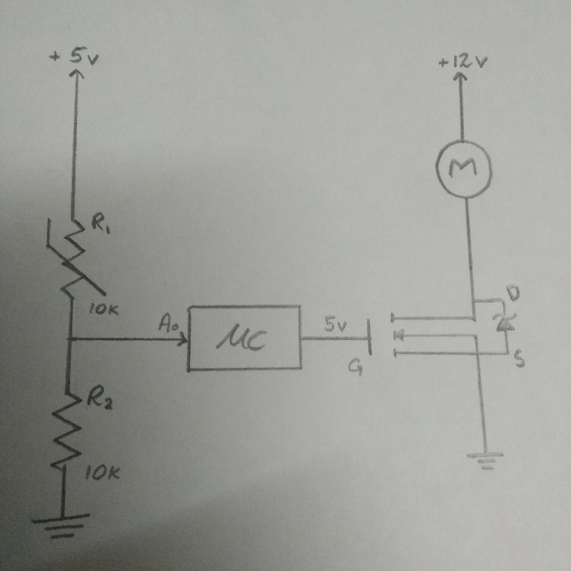

# Steps of Circuit Completion

(*Bifurcate the circuit completion in steps, specify with photographs, leading to final project*)

The pictures of the components used in the circuit are as follows –

***First Phase:***

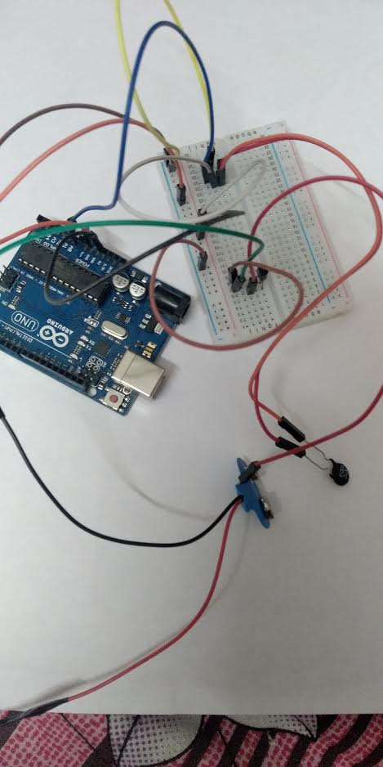

Ardunio Pin 3 connects Mosfet main supply.

Arduino A0 connects to Thermistor Positive side via Breadboard.

Arduino Ground connects to breadboar ground.

Arduino 5V cconnects to positive side of breadboard.

Negative side of Thermistor connects to positive side of Mosfet.

Negative side of mosfet connects to motor’s negative side.

Battery’s positive side connects to motor’s positive.

***Final Phase:***

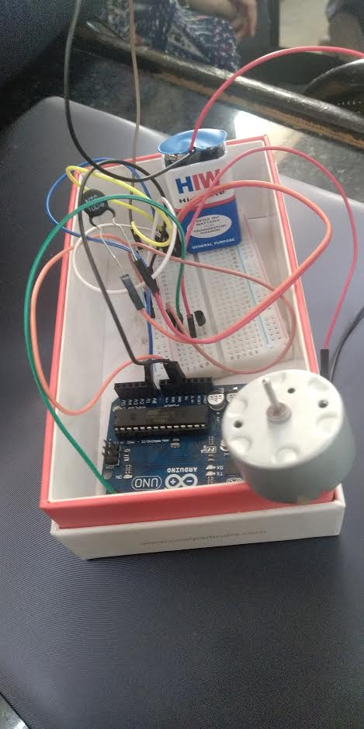

As the Thermistor dectects change in temperaure, it will send a signal to motor to control the speed of your fans or exhaust system.

# Program Code

(*Link of your Github project*)